No 2: Course Compost : Compost and Humus Development.
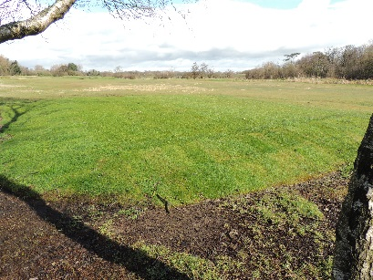
Following on from ‘Course Compost, ways of reusing the golf course’, this subsequent study concentrates on compost development and what to do with the compost/ humus which you have developed at your golf course.
Now you have your grass clippings, leaves and other materials such as shredded cardboard and paper, you thus must know how to develop a good quality compost that can be returned to your golf course. It is actually, quite simple; all that’s required is a front-loading digger and lots of time – the digger to turn over the material and time to allow it to mature.
You will have seen that I mentioned ‘cardboard and paper’ in the previous paragraph - by adding these ingredients, you will create air gaps as the cardboard and paper break down; air is imperative to the success of a compost pile as it allows the tiny organisms to multiply quicker and, as a result, creates the desired end product (humus) earlier. With this in mind, a compost pile should be turned over on a regular basis, perhaps twice per month, however, it is important to remember that once a single pile is deemed large enough (approximately 5m² and approximately 2m high will suffice) then do not continue to place organic material to the top otherwise it will never become mature or stable (by continuously adding fresh organic matter, the microbes, fungi, bacteria and other macro fauna carry on developing heat and the compost pile never actually becomes the finished article).
Composting is a four-stage process beginning with mesophilic (mesophiles, which are bacteria and fungi, invade the organic matter) and then on to thermophilic (bacteria growing in really hot conditions!); maturation (the compost pile begins to mature) and stabilisation (the pile is no longer cooking and is ready to use). It is at the stabilisation stage that our compost is now humus, which is the term used for the microbial decomposition of plant and/ or animal material, and is ready to use!
Where can we use humus?
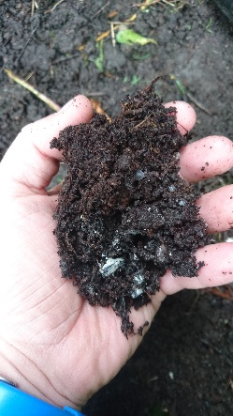
An ideal place would be the clubhouse’s gardens! Simply add the humus to the beds and turn in with a fork. You could give it away to the members or the local community but you cannot sell it unless it has been tested by an independent verifier and your compost must reach the mark of: BSI PAS 100. The details regarding many aspects of compost legislation, including the testing, can be found here: http://www.wrap.org.uk/content/bsi-pas-100-producing-quality-compost
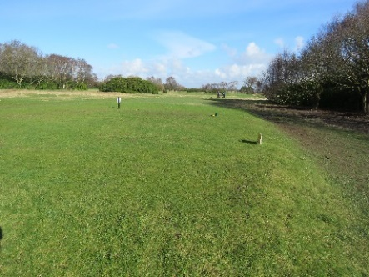
If, however, you do not want to go down the testing route, and I wouldn’t blame you if you didn’t, then how about making a selection of ‘winter enviro tees’, which is another simple task for competent greenkeepers. Simply mix your humus with recycled sand from your bunkers at a 3:1 ratio (sand being the dominant factor) and use as a sub and top soil for a winter tee. Fairhaven Golf Club, Lytham, did just that and won the STRI’s Outstanding Project of the Year Award, 2013!
So, you see, waste products can be a fantastic and easy way of reusing your golf course!

James Hutchinson BSc (Hons), BIGGA Sustainability Executive.

