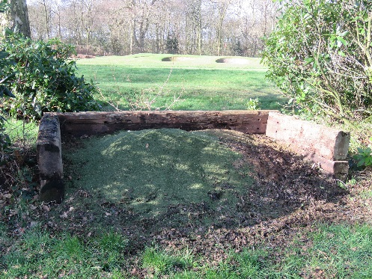
On Course Compost; ways of reusing the golf course.
Environmental management can be a daunting task for those who are not interested in the flora and fauna of their golf courses, however, whether you have an interest or not it has become an integral part of modern greenkeeping.
Many social media sites and online publications have a good number of tips and articles suggesting the correct way to manage your golf course’s environs, as do professional bodies such as the STRI (Sports Turf Research Institute) and the R&A (Royal and Ancient). BIGGA (British and International Golf Greenkeepers
Association) offer conservation advice to its members whilst their magazine, Greenkeeper International, often has articles centred on best ecological practice.
The GTC (The Greenkeepers Training Committee Ltd.) also assists with guidance regarding the aforementioned issues and will be uploading case studies on a monthly basis aimed at environmental matters and their subsequent methods of dealing with the problems faced within the greenkeeping industry. In this first study, we look at recycling and how to create useable material for reuse on a golf course.
Waste Material
Golf courses, as a rule, create grass clippings and the problem often arises with what to do with all the waste which is generated from mowing practices. Some courses such as links and/ or upland chalk have a free draining rootzone and thus do not allow much grass growth during periods of dry weather. However, parkland and other sites which have a clay dominated top and sub layer, are usually ‘grass factories’ meaning they create many clippings.
Many courses simply dispose of their clippings in woodlands or scatter them in the roughs, however, these practices often attract undesirables to the course including yorkshire fog, annual meadow grass and stinging nettle via the collection of nutrients which have resulted in the decomposition of the deposited clippings, not to mention players may land their golf balls in the rotting grass, not ideal.
Another issue with disposing clippings using this method is that it is potentially law breaking. If the decomposing materials find their way into a water course and damages a protected habitat, then the Environment Agency, Woodland Trust and other important groups can potentially close a golf course until the damage is cleared. Again, not ideal.
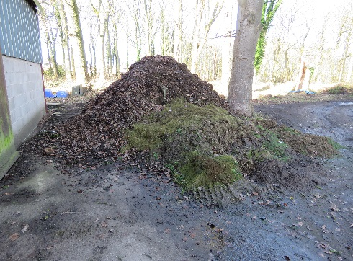
So how do we deal with the waste?
Many courses are now developing small and discreet bays located to the extreme rear of greens and tees for the collection of clippings. These can be made by laying recycled paving stones and then building the edges up with old railway sleepers or other similar timber. You must consider however, that they should be designed large enough to accept a front-loading tractor (to collect the clippings on a weekly or fortnightly basis during the growing season) as collection by hand is a long and laborious task.
Once collected, the clippings should be taken to a main composting station away from public houses, greenkeepers facility and the clubhouse as decomposing organic materials usually gives off a pungent odour. The composting station should be situated on a hard base where the effluent can be returned to the decomposing pile. Ideally, a minimum of three composting piles should be decomposing at any given time as they will be at different stages of decomposition.
Now you know how to deal with your grass clippings, we will return next month to explain how compost is developed and what to do with it all.
James Hutchinson BSc (Hons), BIGGA Sustainability Executive

